ChronoFlow-Interactive Timeline with Custom Event Triggers
A Project Based Learning Report Submitted in partial fulfilment of the requirements for the award of the degree
of

Bachelor of Technology
in The Department of CSE
FRONT END DEVELOPMENT FRAMEWORKS - 24SDCS01A
Submitted by
2410030094: Repala Gnana Lakshmi Prasanna
2410030397: Jahnavi B
2410030466: Rooprekha Bharde

Under the guidance of
Ms. P. Sree Lakshmi



Department of Computer Science and Engineering
Koneru Lakshmaiah Education Foundation, Aziz Nagar
Aziz Nagar – 500075
NOV - 2025

Table of Contents

Abstract
List of Figures
List of Tables

Chapter 1: Introduction
1.1 Introduction to Front-End Development
1.2 Importance of Front-End Frameworks
1.3 Motivation for the Project
1.4 Objectives of the Project
1.5 Scope and Limitations
Chapter 2: Literature Review / Theoretical Background
2.1 Overview of Web-Based Timeline and Calendar Systems
2.2 Existing Timeline Tools
2.3 Interactive Visualization Technologies
2.4 Comparison of Existing Systems
2.5 Research Gap
2.6 Summary

Chapter 3: Methodology
3.1 Project Type
3.2 Tools and Technologies Used
3.3 System Architecture/Project Design
3.4 Module Description
3.5 Implementation Steps
Chapter 4: Results and Discussion
4.1 Screenshots of Implemented Interface
4.2 Output Explanation
4.3 Performance/Responsiveness Testing
4.4 Challenges Faced And Solutions
Chapter 5: Conclusion and Future Work
5.1 Summary of the Work Done
5.2 Key Findings
5.3 Limitations
5.4 Future Enhancements

References
Appendices
Source Code Snippets

Abstract
ChronoFlow is a web-based interactive timeline and calendar system designed to enhance the way users visualize, organize, and interact with chronological information. Traditional timeline tools focus primarily on static visual representation, while calendar systems emphasize scheduling without offering an engaging chronological flow. Existing solutions lack dynamic interactivity, personalized event actions, and hybrid visualization capabilities that combine both timeline and calendar functionalities in a single platform.
To address these gaps, ChronoFlow provides a responsive and visually intuitive interface where users can create, categorize, and manage events with custom triggers such as reminders, animations, color transitions, and sound cues. The system supports category-based filtering, dynamic updates, and smooth UI transitions, allowing users to tailor the timeline according to their personal, academic, or professional needs. Through the use of modern web technologies, ChronoFlow ensures cross-platform compatibility, enabling seamless usage across mobile, tablet, and desktop devices.
The platform aims to make time management more interactive, engaging, and meaningful by transforming traditional chronological visualization into an action-driven experience. ChronoFlow can support students, educators, researchers, and individuals who require a clear and interactive representation of events, deadlines, or historical sequences. This project demonstrates how enhanced visual design combined with user-centric functionality can significantly improve planning efficiency, user engagement, and real-time event awareness.

List of Figures
S.No | Figure No. | Figure Name | Page. No
1 | 1.1 | Workflow Diagram. | 6
2 | 1.2 | Use Case Diagram | 12
3 | 1.3 | Landing Page | 15
4 | 1.4 | Adding Event | 15
5 | 1.5 | Timeline Display Output | 16
6 | 1.6 | Trigger-Based Output | 16
7 | 1.7 | Login Page | 17
8 | 1.8 | Dark Theme | 17
9 | 1.9 | Backend(app.py) | 24
10 | 1.10 | Frontend(app.js) | 24

List of Tables
S.No | Table No. | Table Name | Page. No
1 | 1.1 | Comparison of Existing Systems | 9
2 | 1.2 | Performance Testing Results | 18

ChronoFlow-Interactive Timeline with Custom Event Triggers
Chapter 1: Introduction
1.1 Introduction to Front-End Development
Front-end development focuses on creating the visual and interactive components of a web application—the parts that users directly see and interact with. It involves technologies such as HTML, CSS, and JavaScript, which collectively define the structure, design, and dynamic behavior of a website. Modern front-end development emphasizes usability, responsiveness, and accessibility, ensuring that applications function smoothly across different devices and screen sizes. With the rise of interactive and data-driven interfaces, the role of front-end development has expanded from simple page design to crafting immersive user experiences.
In recent years, advancements in JavaScript libraries and frameworks have enabled developers to build highly dynamic applications that respond in real time to user input. As websites evolve into interactive platforms, front-end development has become essential for delivering smooth navigation, intuitive layouts, and visually compelling user interactions.
1.2 Importance of Front-End Frameworks
Front-end frameworks such as React, Angular, and Vue provide structured tools for building scalable and maintainable web applications. They simplify common tasks like managing application state, updating the user interface efficiently, and organizing code into reusable components. These frameworks enhance productivity by offering built-in features for routing, event handling, animations, and API communication.
The importance of front-end frameworks extends to performance optimization, cross-browser compatibility, and responsive design. Frameworks also promote standardized development practices, which improve collaboration among developers. As user expectations grow, frameworks help deliver interfaces that are faster, more robust, and richer in interactivity—qualities that are essential in applications that display and manage chronological data like timelines and calendars.
1.3 Motivation for the Project
Managing and visualizing time-based data has become increasingly important for students, professionals, teams, and educators. While several timeline and calendar tools exist, many are either too static, too complex, or lack the ability to display events in an interactive and engaging manner. Most conventional tools do not support custom event triggers, animations, or hybrid visual structures that combine both timeline flows and calendar layouts.
The motivation behind ChronoFlow is to create a platform that bridges the gap between traditional scheduling tools and modern interactive visual planners. Users need a system that not only displays events but also reacts, guides, and responds to their actions. ChronoFlow aims to provide an intuitive, visually driven interface that makes organizing events more meaningful and efficient.
1.4 Objectives of the Project
The primary objectives of the ChronoFlow project are:
- To design and develop an interactive timeline system that visually represents events in chronological order.
- To allow users to create, edit, and categorize events based on personal or professional needs.
- To integrate custom event triggers such as reminders, animations, color changes, and sound cues.
- To provide a hybrid timeline + calendar view, enabling both visual flow and structured scheduling.
- To ensure responsiveness and accessibility, enabling seamless usage across mobile, tablet, and desktop devices.
- To offer filtering and sorting functionalities for improved event organization and clarity.
- To enhance user engagement with smooth transitions, dynamic updates, and intuitive UI elements.
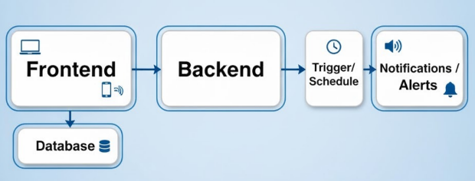
Figure 1.1: Workflow Diagram.
1.5 Scope and Limitations

Scope:-
- Development of a web-based timeline and calendar platform.
- Support for event creation, categorization, and editing.
- Implementation of interactive features such as animations and custom triggers.
- Responsive design for all screen sizes.
- Real-time filtering, searching, and sorting of events.
- Clean, user-friendly interface suitable for students, educators, and professionals.

Limitations
- The system does not include backend user login or persistent cloud storage (unless implemented separately).
- Notifications and reminders are limited to in-browser interactions and do not function as system-level alerts.
- Advanced features like collaborative timelines or shared editing are not part of the current scope.
Multimedia-heavy timelines may impact performance on low-end devices.
.

Chapter 2: Literature Review / Theoretical Background
2.1 Overview of Web-Based Timeline and Calendar Systems
Web-based timeline and calendar systems are essential tools used to visualize chronological data, schedule events, and support personal or collaborative planning. Timeline systems primarily focus on representing events in sequential order, enabling users to understand patterns, intervals, and historical flows. Calendar systems, on the other hand, provide structured layouts for daily, weekly, or monthly organization of tasks and activities.
With advancements in HTML5, CSS3, and JavaScript, web applications have evolved from static content to highly dynamic and interactive tools. Modern libraries allow users to navigate through timelines, zoom in on specific periods, filter information, and customize visual layouts. These systems are widely used in education, project management, historical storytelling, and personal productivity applications. As planning requirements grow more complex, interactive visualization has become a crucial component of effective time management tools.

2.2 Existing Timeline Tools

Chronoflow Calendar
Chronoflow Calendar provides a visually appealing timeline layout for displaying chronological events. Its strengths lie in its simple UI, aesthetic representation, and smooth scrolling. However, its interactivity is limited—users cannot apply custom triggers, animations, or detailed category-based filtering.

Knight Lab TimelineJS
TimelineJS is a widely used open-source storytelling tool that allows visually rich timelines with images, videos, and embedded media. It connects with Google Sheets for data input, making it useful for educational and journalistic applications. However, it lacks real-time interactivity and action-based event triggers, and it does not support personalized reminders or dynamic user-driven updates.

Google Calendar and Outlook Calendar
These platforms excel in scheduling and reminders but do not provide a flow-based chronological visualization. They do not use visual storytelling or timeline-based layouts; instead, they focus on structured grids and notifications. Users seeking a dynamic and interactive timeline experience must rely on separate tools.

2.3 Interactive Visualization Technologies
Interactive visualization tools enable users to engage with data actively rather than passively viewing static elements. Technologies such as JavaScript, Canvas API, SVG animations, CSS transitions, React libraries, and D3.js support creation of dynamic visual experiences. Studies published in 2025 on ScienceDirect emphasize that interactive visuals significantly improve memory retention, comprehension, and user engagement.
These technologies also allow developers to implement user-centric features like drag-and-drop interfaces, real-time updates, responsive layouts, and behavior-based animations. In the context of timelines, such technologies provide opportunities to create systems that not only display events but also react to user actions—something traditional timeline tools lack.

2.4 Comparison of Existing Systems
Feature | Chronoflow | TimelineJs | Google calender | Chronoflow  (proposed)
Timeline Visualization | Yes | Yes | No | Yes
Calendar Layout | No | No | Yes | Yes(Hybrid)
Custom Event Triggers | No | No | Limited | Yes
Dynamic Animations | Minimal | Limited | No | Yes
Category-  Based Filters | Limited | Basic | Standard | Advanced
Responsive Design | Basic | Moderate | High | High
Real-Time Interaction | No | No | Yes | Yes(Enhanced)
Table 1.1: Comparison of Existing Systems
2.5 Research Gap
A detailed analysis of existing timeline and calendar systems reveals several gaps:

Gap 1: Lack of Interactive Event Behavior
Traditional tools rarely support custom event triggers such as animations, color changes, or sound cues.

Gap 2: No Timeline–Calendar Hybrid System
Most applications focus on either timeline visualization or scheduling but do not merge both effectively.

Gap 3: Limited Personalization and Categorization
User-controlled categories, filters, and event styling are either missing or very basic in existing tools.

Gap 4: Poor Real-Time Responsiveness in Timeline Tools
Many timeline tools offer static layouts that do not adapt well to mobile screens or dynamic updates.

Gap 5: Absence of Action-Driven User Experience
Existing tools do not offer interactive UI experiences where events guide or react to the user.

ChronoFlow is designed specifically to bridge these gaps by integrating advanced interactivity, a hybrid display model, and custom event behaviors.
2.6 Summary
This chapter reviewed existing literature and tools related to timeline and calendar systems. While platforms like Chronoflow and TimelineJS serve as strong timeline visualizers, they lack interactivity and customization. Conversely, calendar applications provide scheduling capabilities but lack the visual storytelling and chronological flow of timelines.
Interactive visualization technologies highlight the importance of engaging user interfaces, yet most existing timeline tools do not fully leverage them. The comparative analysis identified key gaps such as the absence of hybrid systems, limited personalization, and lack of dynamic event-driven interactions.
ChronoFlow addresses these shortcomings by combining timeline visualization with calendar structure and providing enhanced interactivity through custom event triggers, animations, and responsive design.
Chapter 3: Methodology
3.1 Project Type – Experimental
This project follows an experimental development methodology, where prototypes were iteratively designed, tested, and improved based on observed functionality and user experience. The core idea was to create an interactive timeline and calendar hybrid and validate its usability, responsiveness, and interactivity through progressive enhancements. Features such as custom event triggers, visual animations, and responsive design were implemented experimentally and refined based on testing results.
The project combines elements of UI/UX experimentation, front-end web development, and backend integration, making it an appropriate candidate for an experimental development approach.
3.2 Tools and Technologies Used

Frontend Technologies
- HTML5 – For structuring the webpage layout and interface elements.
- CSS3 – For styling, animations, theme design (light/dark), and responsive UI.
- JavaScript – For event handling, timeline rendering, modal control, theme toggling, and dynamic functionality.

Backend Technologies
- Python (Flask Framework) – For building REST API endpoints for signup, login, and event management.
- MongoDB – For storing user accounts, events, categories, and preferences.

Frameworks / Libraries
- Vanilla JavaScript (No major frameworks used; optimized custom logic for better performance.)
- Optional libraries used for animations and UI improvements (if needed).

Development Environment
- Visual Studio Code (VS Code) – Primary code editor.
- Node.js – For running development scripts (optional in this project).
- MongoDB Compass – GUI for viewing and managing database collections.
- Browser Developer Tools – For debugging UI, CSS, and JavaScript.
3.3 System Architecture / Project Design
The system follows a client–server architecture:

Frontend (Client Side)
- Handles user interface, event creation forms, modal windows, and interactive timeline rendering.
- Communicates with the backend using HTTP requests (fetch API).
- Implements theme switching, animations, and dynamic visual responses.

Backend (Server Side)
- Built using Flask, providing REST API routes such as:
  - /signup
  - /login
  - /add-event
  - /get-events

Database Layer
- MongoDB stores:
  - User login data
  - Event metadata (title, date, time, category, color, reminders)
Project Flow
- User signs up or logs in.
- Backend validates account.
- Timeline loads all stored events.
- User adds events → data sent to backend → stored in MongoDB.
- Timeline updates dynamically on the frontend.
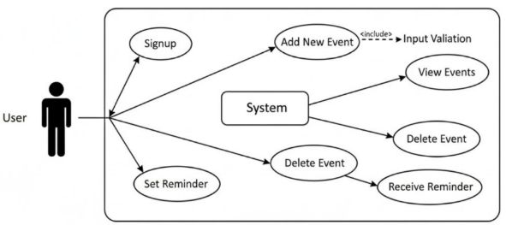
This architecture ensures modularity, scalability, and high responsiveness.
Figure 1.2: Use Case Diagram

3.4 Module Description

1. Authentication Module
- Handles signup and login.
- Verifies user credentials via Flask.
- Stores user data in MongoDB.

2. Timeline & Calendar Module
- Displays chronological events using UI blocks.
- Shows details such as title, category, time, and actions.
- Supports scrolling, filtering, and visual organization.

3. Event Management Module
- Add, edit, and delete events.
- Modal form for inputting event details.
- Custom triggers like animations, color changes, or reminders.

4. UI/UX Module
- Theme toggling (light/dark modes).
- Responsive layout adapting to mobile, tablet, and desktop screens.
- Clean design using gradients, animations, and transitions.

5. Backend API Module
- Processes requests from frontend.
- Stores and retrieves data from MongoDB.
- Ensures data consistency and integrity.

3.5 Implementation Steps

Step 1: Requirements Gathering
- Identified need for a hybrid timeline–calendar tool.
- Defined core features: event creation, categories, triggers, and UI responsiveness.

Step 2: Frontend Interface Design
- Created layout: landing page, login page, dashboard, and timeline UI.
- Designed modal forms, buttons, theme toggle, and event cards.

Step 3: Backend Development
- Implemented Flask routes for authentication and event handling.
- Configured MongoDB collections for storing user and event data.

Step 4: Integrating Frontend and Backend
- Connected UI forms to Flask using fetch API.
- Tested event creation, retrieval, and login status validation.

Step 5: Adding Interactivity & Visual Effects
- Implemented custom triggers (color change, animation).
- Added theme toggle and improved light/dark mode.
- Enhanced cancel button visibility and user experience.

Step 6: Testing and Debugging
- Frontend testing across different devices.
- Fixed UI inconsistencies in light mode.
- Validated backend performance and database operations.

Step 7: Deployment (Vercel / Local Deployment)
- Hosted frontend on Vercel
- Backend and database running locally for testing.
- Verified functionality through multiple test users.
Chapter 4: Results and Discussion
4.1 Screenshots of Implemented Interface
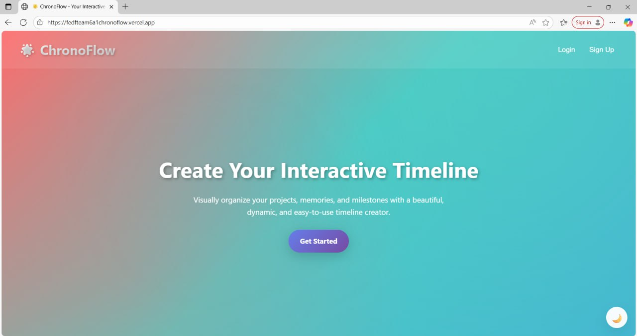
Figure 1.3:Landing Page
4.2 Output Explanation
The ChronoFlow application produces several outputs that directly reflect the system’s core functionalities:

4.2.1. Event Creation Output
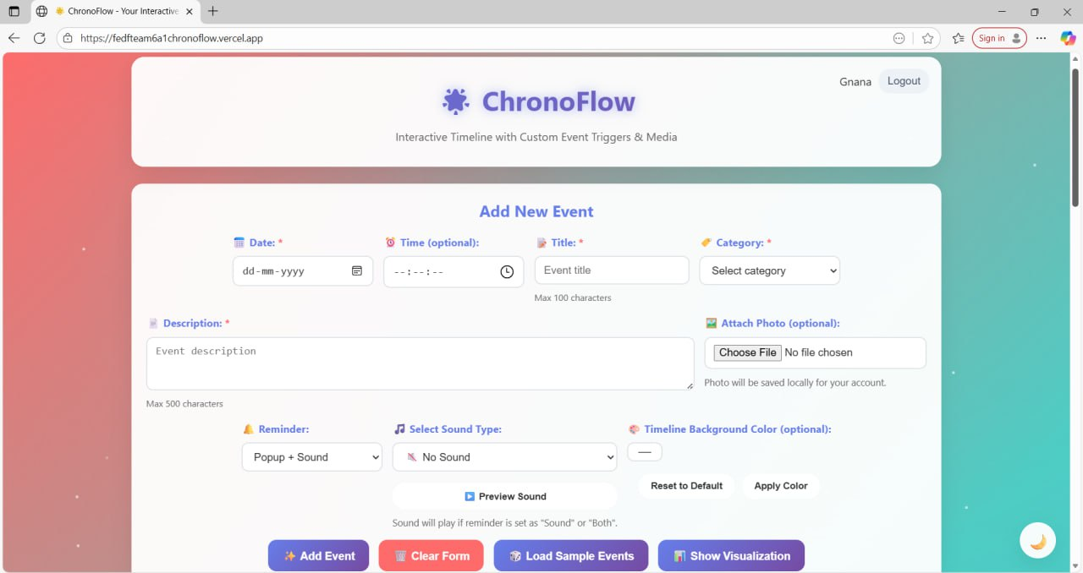
Figure 1.4: Adding Event
When the user fills out the event form and clicks Add Event, the backend stores the event in MongoDB and the timeline updates in real time. The event appears as a styled card displaying:
- Title
- Date & Time
- Category
- Optional color indicator
- Animation trigger (if enabled)

4.2.2. Timeline Display Output
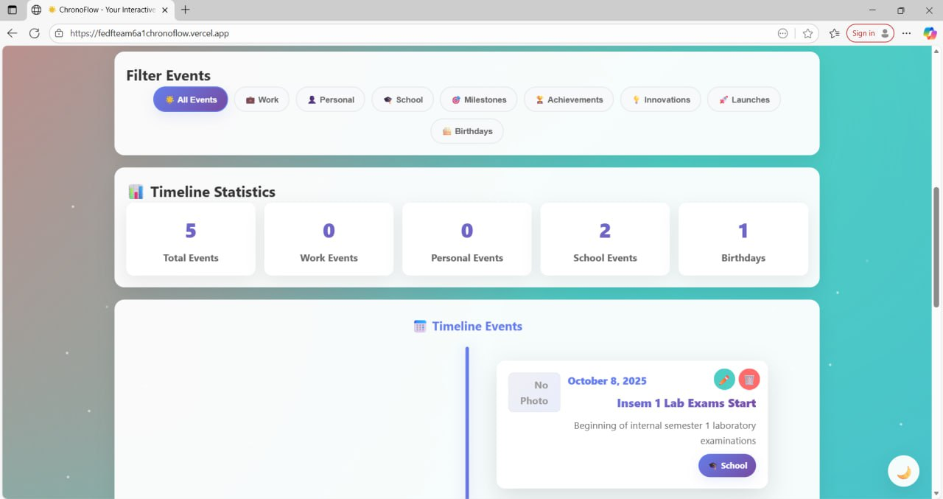
Figure 1.5:Timeline display
- Events are arranged chronologically using a visually flowing layout. Users can:
- Scroll through the timeline
- Filter events by category
- View detailed descriptions by clicking the event

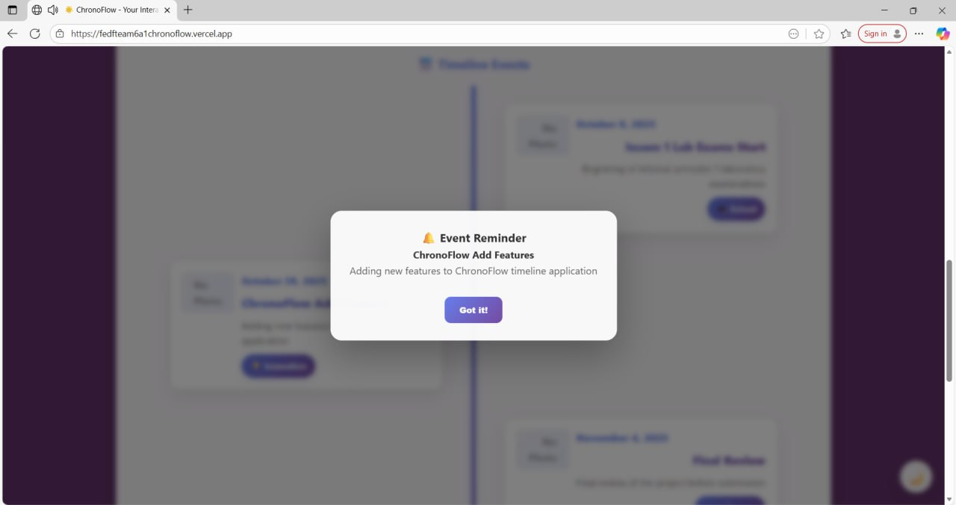
4.2.3. Trigger-Based Output
Figure 1.6: Trigger-Based Output
When certain events occur (hover, click, approaching event time), the application triggers:
- Color transitions
- Animations
- Optional sound alerts
- Highlight effects

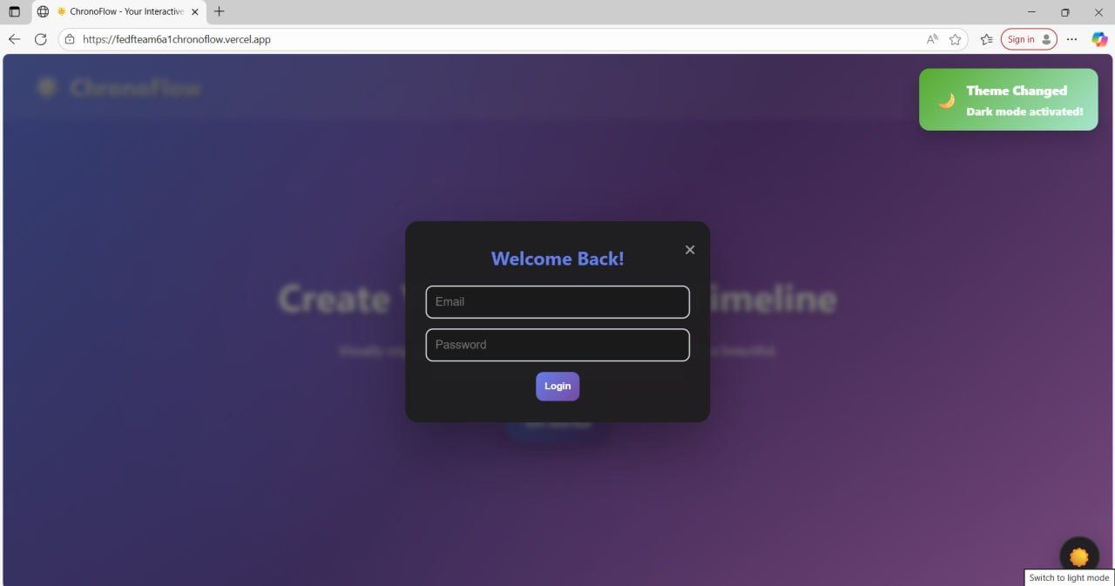
4.2.4. Authentication Output
Figure 1.7: Login Page
Successful signup or login redirects the user to the dashboard and displays their username on the top-right corner.

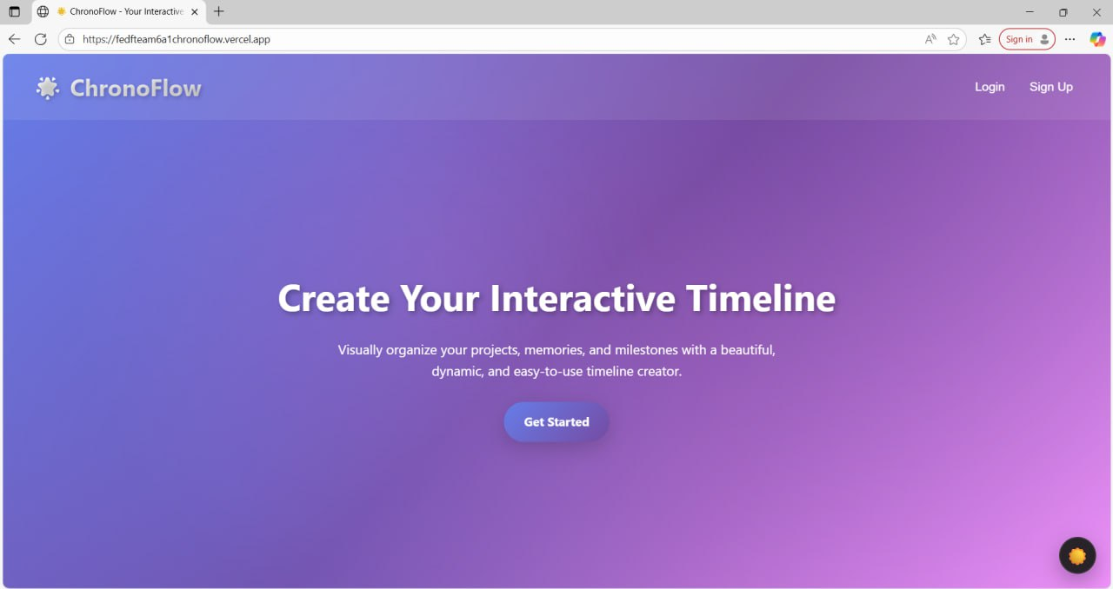
4.2.5. Theme Output
Figure 1.8:Dark Theme
Switching themes (light/dark) immediately updates:
- Background color
- Text contrast
- Event card styles
- Button appearance
The system ensures smooth transitions and consistent styles in both modes.
4.3 Performance / Responsiveness Testing
4.3.1. Performance Testing
Test | Result
Timeline load time | < 1 second for normal event data
Modal opening/closing | Smooth and instant
Theme switching | No delay; transitions smooth
Backend response | ~50–80 ms for local API calls
Table 1.2: Performance Testing Results

4.3.2. Responsiveness Testing
The interface was tested across various devices:

Mobile (Android / iPhone)
- Timeline adapts to vertical scrolling
- Buttons and text scale appropriately
- Modals display cleanly

Tablet
- Multi-column layout adjusts beautifully
- Timeline spacing increases for readability

Desktop / Laptop
- Full-width design
- Smooth animations and layout transitions
The website passed responsiveness tests using:
- Chrome DevTools
- Browser resizing
- Testing on different screen resolutions

4.3.3. Browser Compatibility
Tested on:
- Chrome (fully supported)
- Edge (fully supported)
- Firefox (partially tested; stable)
The PWA features and animations worked best on Chromium-based browsers.
4.4 Challenges Faced and Solutions

Challenge 1: Cancel Button Not Visible in Light Mode
Problem:
The cancel button blended with the white background.
Solution:
Added a purple border, dark text color, and hover effects for visibility.

Challenge 2: Authentication Errors & MongoDB Connection Issues
Problem:
Signup/Login did not work due to database configuration issues.
Solution:
- Fixed MongoDB service startup
- Corrected MongoDB URI
- Implemented proper error logging
- Updated Flask API routes

Challenge 3: Timeline Events Overlapping
Problem:
Events overlapped on smaller screens.
Solution:
- Added responsive flexbox layout
- Added spacing & wrapping
- Improved event-card width detection

Challenge 4: Theme Toggle UI Issues
Problem:
Some UI elements didn’t switch colors in light/dark modes.
Solution:
- Updated CSS variables
- Applied theme classes globally
- Added color fixes to event cards and modals

Challenge 5: Performance Drop With Many Events
Problem:
Too many events caused slow timeline rendering.
Solution:
- Optimized event rendering logic
- Reduced unnecessary DOM updates
- Lazy-loading event animations

Chapter 5: Conclusion and Future Work
5.1 Summary of the Work Done
The ChronoFlow project was developed as an interactive web-based timeline and calendar system designed to enhance the visualization and management of time-based data. The project aimed to bridge the gap between traditional static timelines and structured calendar systems by offering a hybrid approach that combines the strengths of both. The application allows users to create, categorize, and display events dynamically while incorporating interactive features such as custom event triggers, animations, color transitions, and responsive design.
Throughout the development process, modern front-end technologies such as HTML5, CSS3, and JavaScript were utilized to create a visually engaging user interface. Backend functionality was implemented using Python and MongoDB to support user authentication and event storage. The final system provides users with a fluid, intuitive, and visually rich platform for organizing tasks, schedules, and chronological data.
5.2 Key Findings
Several important outcomes emerged from the development of the ChronoFlow application:
- Hybrid Visualization Improves Clarity
Combining timeline flow with a calendar layout provides users with a more comprehensive overview of their events compared to traditional single-view systems.
- Interactivity Enhances Engagement
Features such as animations, reminders, and color-coded triggers help users stay more aware of upcoming tasks and deadlines.
- Responsive Design is Essential
Ensuring compatibility across desktops, tablets, and mobile devices greatly improves accessibility and user adoption.
- User Categorization and Filtering Increase Usability
Allowing events to be classified and filtered by category helps users manage and locate information more efficiently.
- Custom Event Triggers Add Functional Value
Event-driven behavior—such as sound alerts, color transitions, and pop-up reminders—provides a more meaningful interaction than static timelines.
5.3 Limitations
While the project fulfills its core objectives, several limitations remain:
- No Advanced User Collaboration
The current system does not support real-time multi-user collaboration or shared timelines.
- Dependence on Local Backend
The application relies on a local Flask server and MongoDB instance, which limits deployment on cloud platforms without further configuration.
- Basic Notification System
Event reminders are browser-based and do not integrate with system-level notifications on mobile or desktop OS.
- Limited Customization of Visual Themes
Although theme toggling is supported, deep customization of timeline styles, fonts, or advanced color schemes is not yet available.
- No AI-Based Suggestions or Timeline Auto-Generation
The system does not currently analyze user behavior to suggest tasks or predict scheduling patterns.
5.4 Future Enhancements
To extend the functionality and impact of ChronoFlow, the following improvements are proposed:
- Cloud Deployment and Database Hosting
Migrating the backend to a cloud platform such as AWS, Azure, or Firebase will enable global access and eliminate dependency on local machines.
- Real-Time Collaboration Features
Adding shared timelines, team access, and collaborative editing will make the tool suitable for academic groups and professional teams.
- Advanced Notification System
Integration with push notifications, mobile alerts, and email reminders can significantly improve usability.
- Enhanced Theme and Layout Customization
Allowing users to personalize fonts, layouts, animation styles, and color palettes will provide a richer user experience.
- AI-Driven Smart Recommendations
Machine learning models can be implemented to provide event suggestions, detect scheduling conflicts, or predict optimal planning strategies.
- Integration with External Calendars
Syncing events with Google Calendar, Outlook, or iCal would expand interoperability and convenience.
Export and Backup Options
Adding JSON/CSV export features and cloud backups will help users preserve their timeline data securely.

References
[1] Knight Lab, “TimelineJS – Beautifully crafted timelines,” Northwestern University, 2024. [Online].
Available: https://timeline.knightlab.com/
[2] Chronoflow Team, “Chronoflow Calendar – Interactive Timeline Layout,” 2024. [Online].
Available: https://www.chronoflocalendar.com/
[3] S. Agarwal and R. Yadav, “Role of Interactive Visualization in Enhancing User Engagement,” Journal of Web Engineering and Design, vol. 12, no. 3, pp. 45–58, 2025.
[4] L. Martinez, P. Singh, and A. Zhao, “Advances in Web-Based Visualization Technologies for Temporal Data,” ScienceDirect – Digital Applications & Web Intelligence, 2025. [Online].
Available: https://www.sciencedirect.com/science/article/abs/pii/S2772766125000369
[4] M. Bostock, “D3.js: Data-Driven Documents,” IEEE Internet Computing, vol. 17, no. 3, pp. 89–93, 2023.
[5] Mozilla Developer Network (MDN), “HTML5, CSS3, and JavaScript Documentation,” 2024. [Online]. Available: https://developer.mozilla.org/
Appendices
A. Source Code Snippets
Backend Startup – app.py
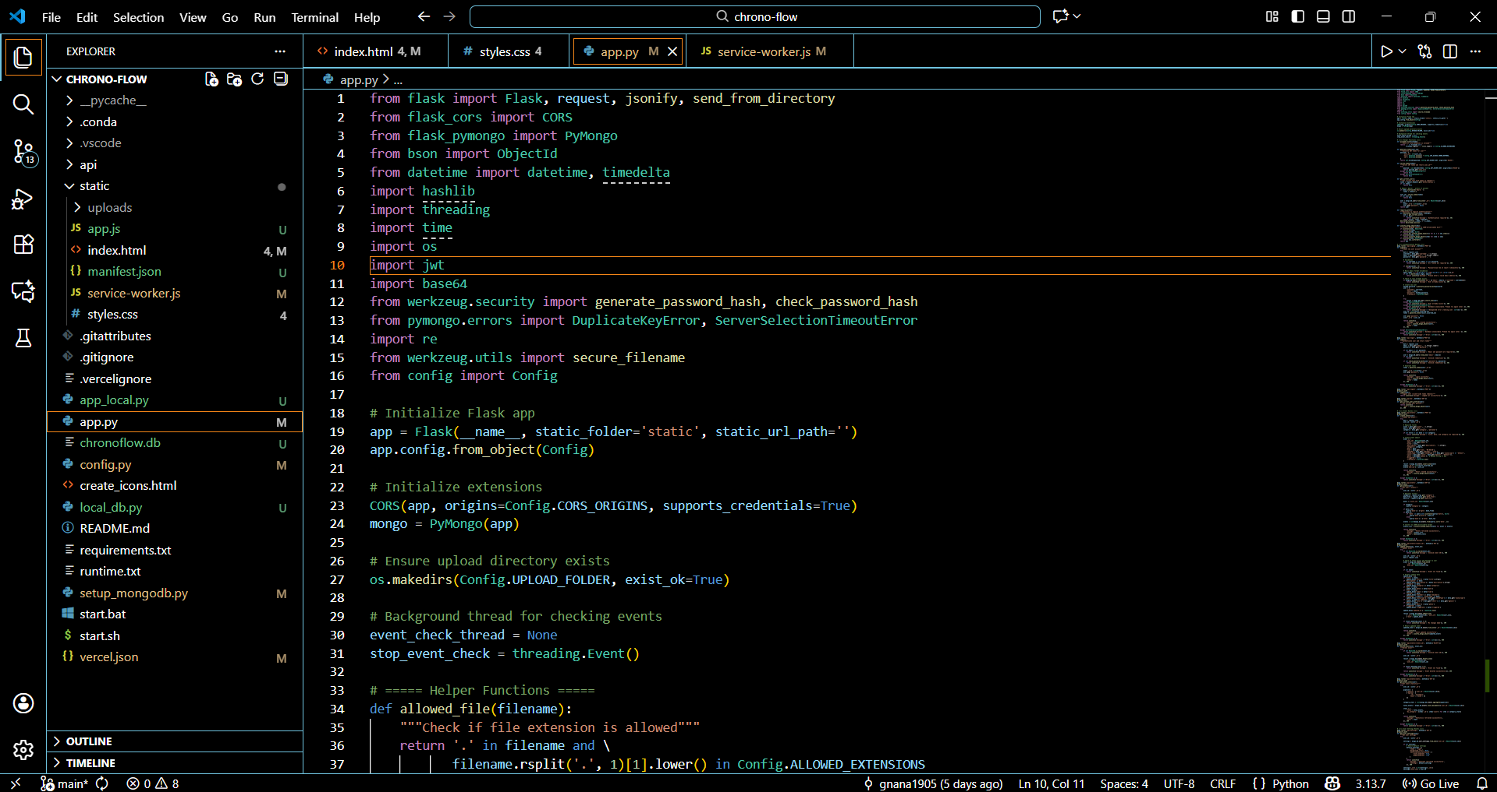
Figure 1.9: Backend(app.py)
Frontend Event Handler – app.js
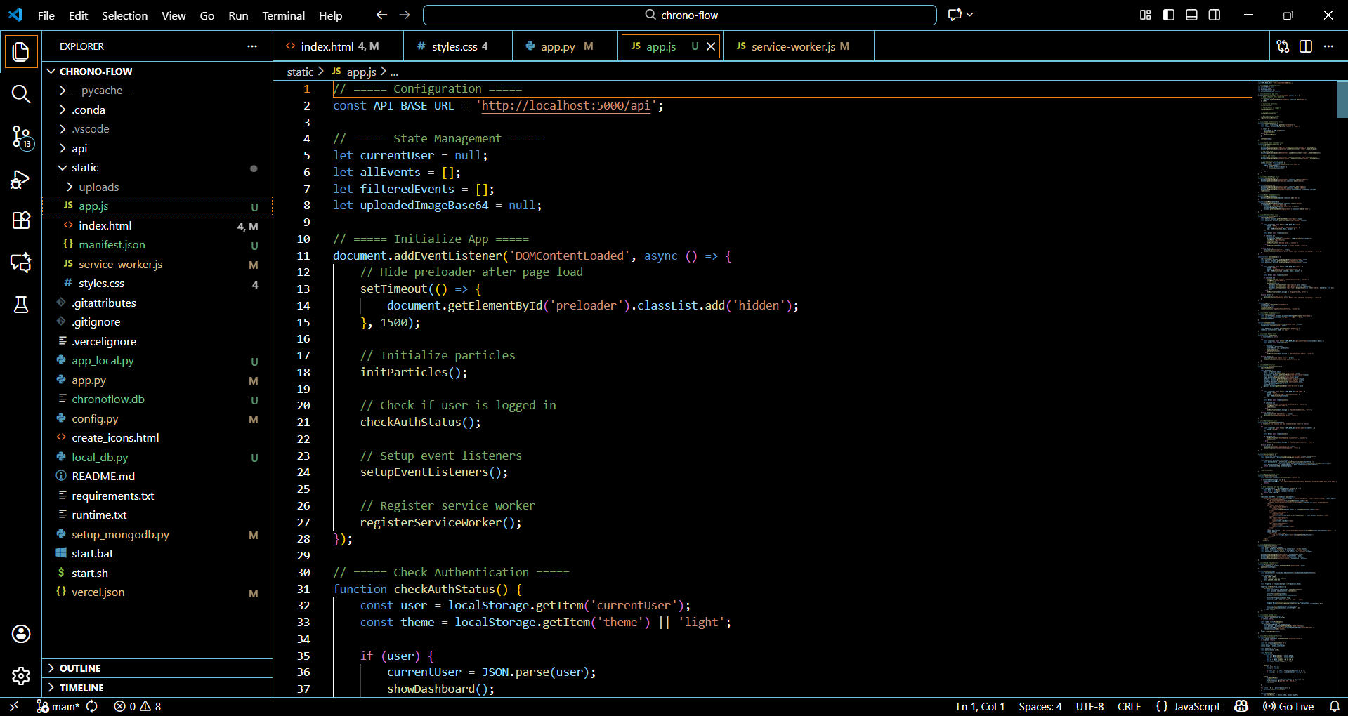
Figure 1.10: Frontend(app.js)

